{SPRING INTERNSHIP PROJECT REPORT FORMAT}

Driver Drowsiness Detection System

Ranjith J K,
B.Tech-(AI & DS) – Sona College of Technology

Period of Internship: 21ST January 2026 – 17TH February 2026

Report submitted to: IDEAS – Institute of Data Engineering, Analytics and Science Foundation,
ISI Kolkata

Abstract

Driver drowsiness is one of the major causes of road accidents across the world. This project focuses on developing a real-time driver drowsiness detection system using computer vision techniques. The system uses a webcam to capture live video and continuously monitor the driver's eye movements. If the driver's eyes remain closed for a certain period of time, the system detects drowsiness and triggers an alert sound to wake the driver.

The implementation uses Haar Cascade classifiers for detecting the face and eyes. The system is lightweight, efficient, and capable of running in real-time without requiring high computational power. This makes it suitable for practical deployment in vehicles. The main goal of this project is to improve road safety and reduce accidents caused by fatigue.

Introduction

Road accidents due to driver fatigue have become a serious issue in recent years. Long driving hours, lack of sleep, and monotonous roads often lead to drowsiness, which significantly reduces reaction time and attention. Early detection of such conditions can help prevent accidents and save lives.

This project aims to develop a system that can detect driver drowsiness using a simple webcam and computer vision techniques. The system monitors the driver's eyes and determines whether they are open or closed. If the eyes remain closed for a specific duration, the system considers the driver to be drowsy and generates an alarm.

The project is implemented using Python and OpenCV. Haar Cascade classifiers are used for detecting facial features such as the face and eyes. The project also covers fundamental concepts such as image processing, real-time video analysis, and basic machine learning ideas.

Project Objectives

The main objectives of this project are:

• To detect the driver's face using a webcam in real-time • To accurately detect and track the driver's eyes • To monitor eye closure duration continuously • To identify drowsiness based on eye closure patterns • To trigger an alert sound when drowsiness is detected • To design a simple, cost-effective, and efficient system • To improve road safety and reduce accident risks

System Architecture

The system consists of the following components:

Webcam – Captures real-time video input
Processing Unit – Executes the detection algorithms
Haar Cascade Classifier – Detects face and eyes
Drowsiness Detection Logic – Tracks eye closure duration
Alarm System – Alerts the driver when drowsiness is detected

The workflow begins with capturing video frames from the webcam. Each frame is processed and analyzed to detect facial features. Based on the analysis, the system determines whether the driver is alert or drowsy.

Methodology

The methodology of the project involves several steps. First, the webcam captures live video frames continuously. Each frame is converted into grayscale to simplify processing and improve detection speed.

Next, the Haar Cascade classifier is used to detect the face in the frame. Once the face is detected, the eye detection classifier is applied within the face region. If the eyes are detected, the system assumes that the driver is alert.

If the eyes are not detected for consecutive frames, a counter is incremented. When this counter exceeds a predefined threshold value, the system concludes that the driver is drowsy. At this stage, an alarm sound is triggered to alert the driver.

Python threading is used to handle the alarm system separately, ensuring that the main video processing loop runs smoothly without interruption.

Implementation Details

The project is implemented using the following tools and technologies:

• Programming Language: Python • Library: OpenCV • Detection Technique: Haar Cascade Classifier • Development Environment: Jupyter Notebook / Python IDE

The Haar Cascade model used in this project is a pre-trained model that can detect objects based on features. It is widely used due to its speed and simplicity. The system processes each frame in real-time and provides immediate feedback.

Data Analysis and Results

The system was tested under different real-time conditions to evaluate its performance. In well-lit environments, the system performed accurately and consistently detected the driver's eyes.

When the driver closed their eyes for a longer duration, the system successfully detected drowsiness and triggered the alarm. The response time was quick, making the system effective for real-time applications.

However, some limitations were observed during testing. In low-light conditions, the accuracy of detection decreased. Similarly, when the driver wore sunglasses or partially covered their face, the system struggled to detect the eyes properly.

Despite these limitations, the system demonstrated reliable performance under normal conditions.

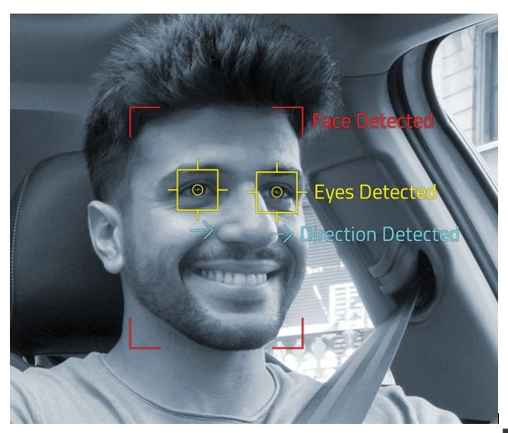

DETECTION
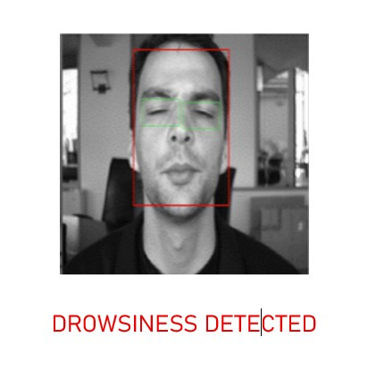

Advantages of the System

• Real-time detection of driver drowsiness • Simple and easy to implement • Low cost and does not require expensive hardware • Lightweight and fast processing • Can be integrated into existing vehicle systems

Limitations of the System

• Reduced accuracy in low-light conditions • Difficulty in detecting eyes with sunglasses • Limited robustness compared to deep learning models • Depends heavily on camera quality and positioning

Future Enhancements

The project can be improved in several ways:

• Integrating deep learning models for better accuracy • Adding yawning detection and head movement tracking • Improving performance in low-light conditions • Using infrared cameras for night-time detection • Deploying the system in real vehicles for real-world testing

Conclusion

This project successfully demonstrates a driver drowsiness detection system using computer vision techniques. By monitoring eye closure and generating alerts, the system helps in preventing accidents caused by fatigue.

The system is simple, efficient, and cost-effective, making it suitable for practical applications. Although there are some limitations, they can be addressed through future improvements. Overall, this project highlights the importance of technology in enhancing road safety.

Appendices
References

• OpenCV Documentation • Python Official Documentation

Report & Data Link

https://drive.google.com/drive/folders/1vtj0_Wh9nvgds1TBftS86FeaaLLU-1NU?usp=sharing

